**Observer pattern**

***Code Snippet***

This pattern is caracterized by mantaining a list of observers and notify them, thus update them of any change of state.

**Strutcture**

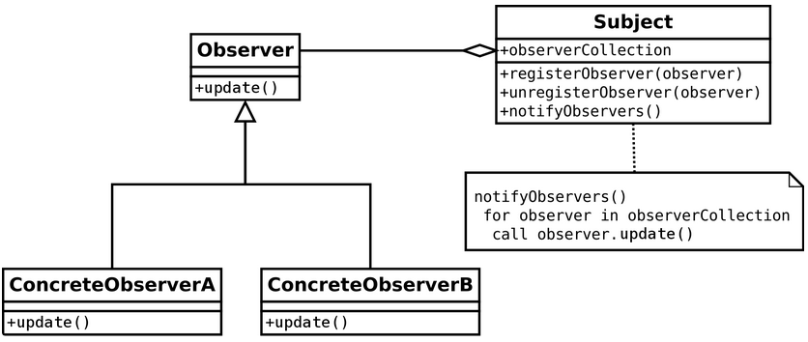

**Code location**

Registers the new listener

Src/main/java/org/jabref/gui/LibraryTab/

Methods that update/notify the listeners by adding or removing an entry

Src/main/java/org/jabref/gui/LibraryTab/IndexUpdateListener

**Justification**

As shown above, the observer pattern is being used because everytime an entry is either added or removed, all the listeners will update.

In this case, the observe ris the indexUpdateListenerClass and the subject, the LibraryTab class.

Although it is not present an unregister listener method, it still can be considered an observer pattern.